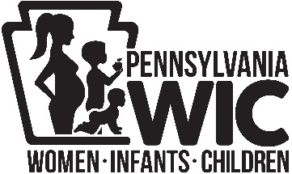2019 WIC Public Meetings Comment Form

Pennsylvania Department of Health

Bureau of Women, Infants and Children (WIC)

Attention!

Your comments and suggestions for the WIC program are important to us! What are we doing right? Where is improvement needed?

If you are unable to attend one of the public meetings, please complete this comment form and give to the WIC director or staff. You may also submit your comments and suggestions by email to Bonnie Mellott at the WIC State Agency at [bmellott@pa.gov](mailto:bmellott@pa.gov) or mail to Bureau of WIC, 625 Forster Street, 7 West, Health and Welfare Building, Harrisburg, PA 17120 by May 31, 2019. Thank you!

**__________________________________________________________________________________________________________________________________________________________________________________________________________________________________________________________________________________________________________________________________________________________________________________________________________________**

2019 WIC Public Meetings Comment Form

Pennsylvania Department of Health

Bureau of Women, Infants and Children (WIC)

Attention!

Your comments and suggestions for the WIC program are important to us! What are we doing right? Where is improvement needed?

If you are unable to attend one of the public meetings, please complete this comment form and give to the WIC director or staff. You may also submit your comments and suggestions by email to Bonnie Mellott at the WIC State Agency at [bmellott@pa.gov](mailto:bmellott@pa.gov) or mail to Bureau of WIC, 625 Forster Street, 7 West, Health and Welfare Building, Harrisburg, PA 17120 by May 31, 2019. Thank you!

**__________________________________________________________________________________________________________________________________________________________________________________________________________________________________________________________________________________________________________________________________________________________________________________________________________________**